

***System Provisioning and Configuration Management***

***Submitted by:***

***NAME: Tanishqua Tellakula***

***SAP ID: 500084269***

***Roll number: R120220007***

***Batch: B1(Hons)***

***EXPERIMENT 2***

***Terraform AWS Provider Configuration***

***Prerequisites:*** *Terraform Installed: Make sure you have Terraform installed on your machine. Follow the official installation guide if needed.*

***Exercise Steps:***

***Step 1: Create a New Directory:***

*Create a new directory for your Terraform configuration:*

| *Terraform-Demo* |
| --- |

***Step 2: Create Terraform Configuration File (main.tf):***

*Create a file named main.tf with the following content:*

| ***terraform {***  ***required_providers {***  ***aws = {***  ***source = "hashicorp/aws"***  ***version = "5.30.0"***  ***}***  ***}***  ***}***  ***provider "aws" {***  ***}*** |
| --- |

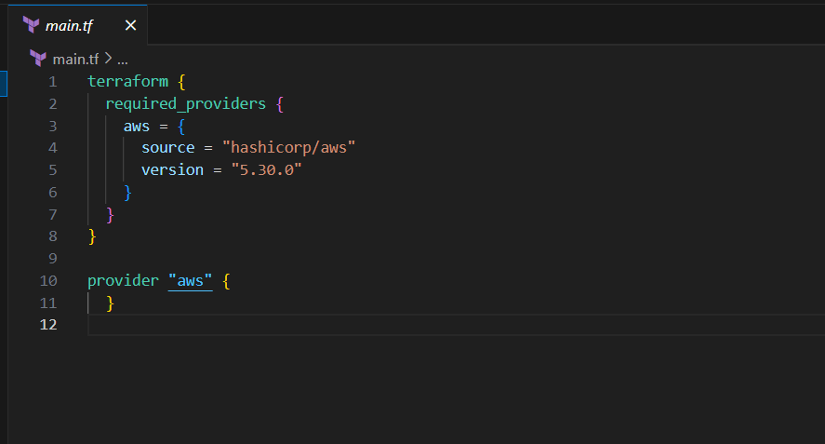

***Step 3: Initialize Terraform:***

*Run the following command to initialize your Terraform working directory:*

| ***terraform init*** |
| --- |

